**Deep Drawdowns at Rimrock Lake are Associated with Decline in Bull Trout Redd Counts the Following Year**

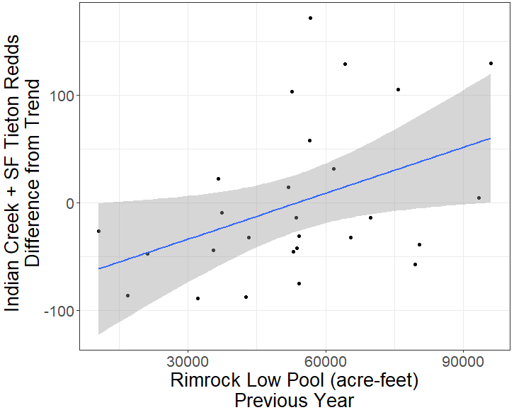

**September 12, 2024**

David Dayan, USFWS-ES Washington Fish and Wildlife Office

Craig Haskell, USFWS-FAC Mid-Columbia Fish and Wildlife Conservation Office

Executive Summary

Fish, including bull trout, are entrained from Rimrock Lake through the unscreened outletworks of Tieton Dam. Operations to support flip-flop irrigation deliveries in the late summer and early fall can lead to deep drawdowns of Rimrock Lake that will likely increase in frequency. Deeper drawdowns are also associated with greater entrainment of kokanee, important prey for bull trout. Rimrock drawdowns may therefore have the effect of both removing fish from upstream spawning populations and negatively affecting the prey base for bull trout that are not entrained. To better understand the potential effects of Rimrock drawdowns on bull trout, we examined redd count data, reservoir storage, and snowpack from 1994 to 2023. After accounting for the overall trend towards decline, we found that there is a significant association between the magnitude of drawdown at Rimrock Lake (minimum annual pool volume) and the number of bull trout redds observed the following year in the South Fork Tieton River and Indian Creek populations.

The final model predicts a loss of 34 redds in the year following a drawdown to 30,000 acre-feet (af). This predicted loss of redds is in addition to the overall trend towards decline. No similar association was observed between the minimum annual pool volume and redd counts two and three years later. In a model that included both snowpack and minimum annual pool volume, we found that only minimum annual pool volume improved the fit to the data.

Future PIT and acoustic monitoring of these populations would further elucidate the effect of drawdown of Rimrock Lake on bull trout. However, given the timeline for implementing fish passage at Tieton and other Yakima Project dams, short term solutions such as exclusion nets or screens need investigation.

Background

Construction of the Tieton Dam in 1925 impounded Rimrock Lake and isolated three local populations of bull trout above the dam: North Fork Tieton River, South Fork Tieton River, and Indian Creek. Clear Creek Dam further fragments habitat in the area by limiting migration along the North Fork Tieton River between Rimrock Lake and the upstream Clear Lake. No natural lake existed in the area and these local populations likely expressed a fluvial life history prior to construction of Tieton and Clear Creek dams. Currently, all three populations express an adfluvial life-history; using individual tributaries to spawn and returning to reservoir habitats to forage and overwinter.

The Rimrock populations share several threats related to the presence and operation of Tieton Dam. In addition to blocking upstream passage, Tieton Dam entrains fish through its unscreened outlet works. Rimrock Lake is rapidly drafted in late summer and early fall to support “flip-flop” operations of the Yakima Project and meet irrigation demands (Fig. 1). The rate of entrainment for fish in reservoir habitats is determined by forebay habitat usage and the velocity at the intake (Coutant & Whitney, 2000; Harrison et al., 2019, 2020). Many adult Rimrock bull trout are expected to be in upstream spawning habitats during peak flip-flop water delivery (Fig. 1). However, adult Rimrock bull trout have been documented in the forebay during the period when peak flows occur (Mizell & Anderson, 2008, p. 42), and many subadult bull trout are expected to remain in Rimrock Lake throughout the year. Genetic stock identification of bull trout collected in stilling basin just below Tieton Dam assigned fish to all three local Rimrock populations (Small et al., 2009, p. 26), confirming that entrainment occurs.

Studies conducted in 2002 and 2003 estimated 145 and 120 bull trout were potentially entrained from Rimrock Lake each year, respectively (Hiebert, 2004, p. 18; Hiebert et al., 2003, p. 12). These estimates may be spuriously large due to the possibility of non-entrained bull trout entering the study nets, and confidence interval of these estimates are also large (2002: 60 – 900). Twenty percent of the potentially entrained bull trout were adults, while the remaining entrained bull trout were subadults (Hiebert, 2004, p. Appendix B; Hiebert et al., 2003, p. Appendix B). Given population estimates in South Fork Tieton River and Indian Creek at the time (James, 2002, pp. 59, 64), this represents an estimated annual entrainment rate of about 0.6 – 9.2% of the spawning population. The drawdowns in 2002 and 2003 were typical since “flip-flop” began with minimum annual pool volumes of 53,762 and 42,640 af, respectively.

Entrained bull trout likely suffer injury and mortality (Algera et al., 2020). While the rate of injury and mortality for adult bull trout entrained through Tieton Dam is unknown, kokanee have been used as surrogates to estimate mortality for sub-adult bull trout. Mortality is estimated at 45% for sub-adults (Courter & Vaughan, 2011). Bull trout that survive entrainment are permanently displaced from the lake and unable to contribute to the productivity of their natal streams. Few entrained fish at Tieton Dam are expected to spawn elsewhere (Mizell & Anderson, 2015, p. 108).

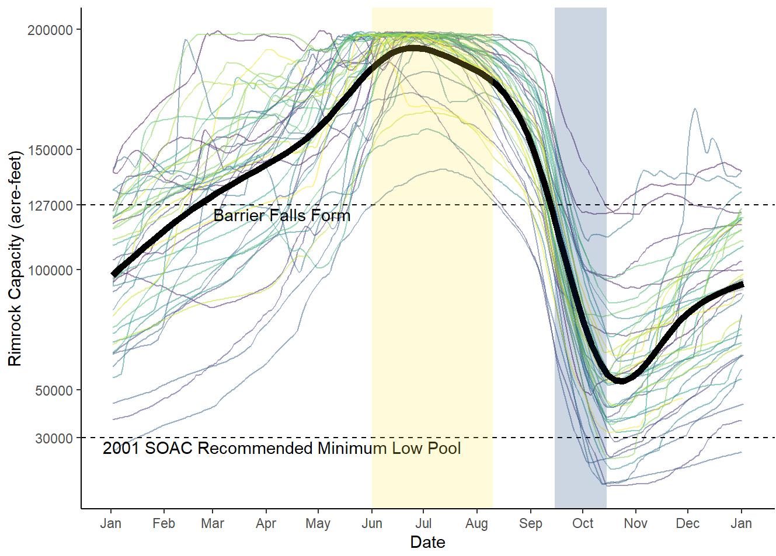

**Figure 1:** Volume of Rimrock Lake through the year demonstrating drawdown, and the overlap of flows with migration timing and formation of a passage barrier at the mouth of South Fork Tieton River. Colored lines are individual years from 1981- 2023, with more recent years in lighter (yellow) colors. Yellow period from June to mid-August approximates peak upstream spawning migration for South Fork Tieton River, blue period from mid-September to mid-October approximates peak downstream, post-spawn migration of adults (James, 2002). Heavy black line is loess-smooth of all years. Rimrock Volume Data from Bureau of Reclamation-Hydromet.

Drawdowns of Rimrock Lake also pose a threat to bull trout through impacts on the prey base. Unlike most reservoirs in the Yakima Project (Keechelus, Kachess, Bumping, Cle Elum), Rimrock Lake was not previously a natural lake, and operations at Tieton Dam can draw Rimrock down to extremely low levels. Complete drawdowns of Rimrock Lake occurred four times, (1926, 1931, 1973, and 1979), and are associated with collapse of the Rimrock kokanee fishery the following year (Mongillo & Faulconer, 1980). The kokanee fishery did not recover from the 1973 drawdown for six years, despite stocking, and 95 – 99% of the population was lost to entrainment during the 1979 drawdown (Mongillo & Faulconer, 1980, pp. 31, 35). Analysis of kokanee catch records also indicate that deep drawdowns, defined as those below ~30,000 af, measurably reduce kokanee abundance and productivity the following year (Mongillo & Faulconer, 1980, p. 31), prompting the Yakima Systems Operation Advisory Committee (SOAC) to recommend operating Rimrock Lake above this level in 2001. Rimrock has been drafted beneath 30,000 af eight times since 1981, but only once since the 2001 recommendation (Fig. 1).

Importantly, the 30,000 af threshold identified by Mongillo and Falconer (1980, p. 31) is an arbitrary cut-off derived from limited data, and not evidence that the rate of entrainment rises sharply at a particular Rimrock pool volume. Indeed, peak entrainment of age-0 kokanee during the 1979 drawdown occurred at a reservoir level of 67,000 af (Mongillo & Faulconer, 1980, p. 36). Hiebert *et al* found that flow rates through Tieton Dam were a better predictor of kokanee entrainment than forebay elevation (2003, p. 13; 2004, p. 18), and the greatest entrainment rate of kokanee occurred while Rimrock elevation was ~2,900 ft msel (equivalent to ~139,000 acre feet) (2003, p. 14; 2004, p. 20).

While studies using tagging (Mizell & Anderson, 2008, 2015), genetic stock identification (Small et al., 2009), netting (Hiebert, 2004, 2004), and fishery records (Mongillo & Faulconer, 1980) indicate that entrainment poses a risk to Rimrock Lake bull trout populations, neither the extent of entrainment that occurs each year, nor the relationship between Tieton Dam operations and entrainment rate are well understood. Future monitoring efforts using PIT and acoustically tagged sockeye and bull trout are likely to provide answers to these questions. However, available redd count data may provide immediate insights. In this report, we examine if the bull trout redd counts in South Fork Tieton River and Indian Creek are associated with the extent of drawdown in previous years.

**Methods**

To explore the potential relationship between drawdown and entrainment risk in bull trout we considered redd count data, reservoir storage, and snowpack. Redd count data have been collected during spawning ground surveys in the Yakima basin since 1984 (Divens, 2024). Only probable and definite redds are included in redd count data (Divens, 2024, p. 5). Among the three populations that use Rimrock Lake to forage and overwinter, reliable redd count data from index reaches are available since 1988 in Indian Creek, 1994 in South Fork Tieton River, and 2007 in North Fork Tieton River (Divens, 2024, p. 25). To reduce the influence of stochastic events that influence redd counts at the local population scale, and focus on Rimrock-wide effects, we summed redd counts across populations. The data was filtered to exclude any year with an incomplete spawning survey in any population. Including North Fork Tieton strongly reduced sample size (*n* = 27 *vs. n =* 13), so we chose to exclude North Fork Tieton River from the analysis. Summed redd counts were then detrended using a linear regression against year. Residuals from this regression (*redd_residuals)* were used as the dependent variable in all following models.

Hydological data was collected from Bureau of Reclamation Hydromet Service (https://www.usbr.gov/pn/hydromet/yakima/yakwebarcread.html). We collected daily Reservoir Water Storage for Rimrock Lake (af) from January 1, 1981 to November 27, 2023. Environmental data was collected from the Natural Resources Conservation Service database. We collected April 1st Snow Water Equivalent at the White Pass E.S, WA SNOTEL site (SNOTEL 863) for all years from 1981 to present.

We fit a linear model of *redd_residuals* using minimum annual reservoir water storage (af) in Rimrock Lake one, two, and three years prior (*rim_1*, *rim_2,* and *rim_3*, respectively). We chose minimum annual reservoir water storage (*rim_1*, *rim_2,* and *rim_*3) over other variables that capture the extent and duration of winter drawdown at Rimrock Lake to maintain precedent with previous analyses (Mongillo & Faulconer, 1980) and SOAC recommendations, and to better relate our results to operational decisions at Tieton Dam. The saturated model was validated using residual, QQ, and leverage plots in R. We then conducted backwards stepwise model selection based on likelihood ratio tests for each predictor, and a p-value cutoff of 0.05. Statistical significance of the correlation between *redd_residuals* and the remaining predictors was conducted using a t-test, and a p-value cutoff of 0.05.

To parse the role of drawdown depth the previous year from potential environmental effects, we also fit a linear model on *redd_residuals* using *rim_1* and April 1st snow water equivalent at the White Pass SNOTEL site the prior year (*swe_1*). After model validation, we calculated correlation between *rim_1* and *swe_1,* and the variance inflation factor. We then conducted backwards stepwise model selection based on likelihood ratio tests for each predictor, and a p-value cutoff of 0.05.

Detailed computational logs and all data from this report are available at a github repository, <https://github.com/david-dayan-usfws/Rimrock-Drawdown>. An R notebook containing narrative logs of all analyses with integrated code, results, and commentary is available at <https://rpubs.com/david_dayan/rimrock_drawdown>

Results and Discussion

*Redd Count Trends*

There was a trend towards decline in redd counts in South Fork Tieton River and Indian Creek from 1994 to 2023 (Fig. 2). This trend may reduce power or lead to spurious associations if the depth of past drawdowns is not evenly distributed over time. Therefore, we used residuals from the linear regression against year (*redd_residuals*) as the dependent variable in all following models.

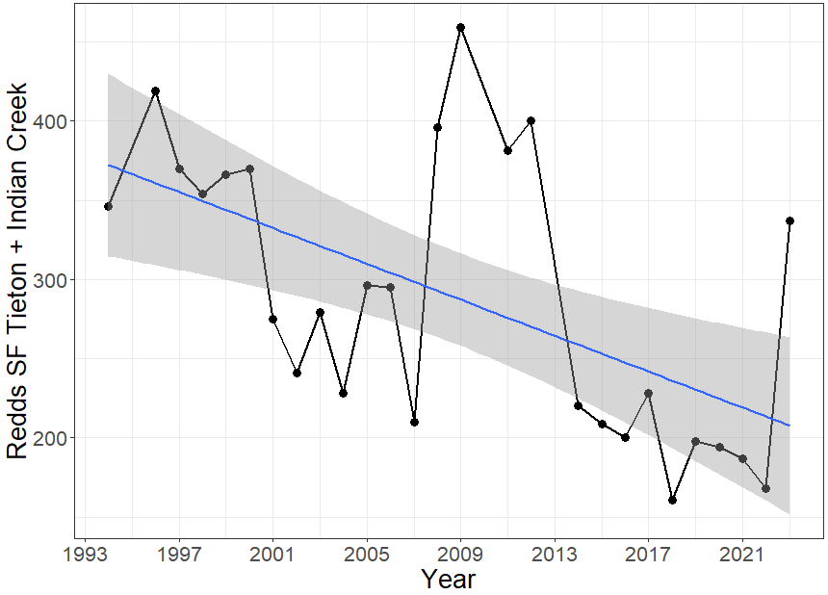

Fig. 2: Sum of redd counts in South Fork Tieton River and Indian Creek from 1994 to 2023. Line is a linear regression against year, and its 95% confidence interval. Incomplete survey years are excluded.

*Association of Redd Counts with Rimrock Drawdown in Previous Years*

After model selection, our final model included only *rim_1* as a predictor of *redd_residuals* data. There was a significant correlation between detrended redd counts in South Fork Tieton River and Indian Creek (*redd_residuals)* and the extent of drawdown at Rimrock Lake the previous year (*rim_1*) (t-test, p = 0.0299, Fig. 3). This result suggests that deep drawdowns are associated with a loss of redds the following year, greater than the overall trend towards decline. The final model predicts a loss of 34 redds following a drawdown to 30,000 af. This predicted loss of redds is in addition to the overall trend towards decline.

We focused on the 30,000 af cutoff based on the previous recommendation by the Yakima SOAC to maintain Rimrock Lake above this level. However, it is not clear if 30,000 af represents a sharp inflection point in the relationship between *rim_1* and *redd_residuals*. For example, in eight of the nine years when Rimrock Lake was drafted below 50,000 af, fewer redds were observed the following year than predicted from the annual trend (Fig. 3).

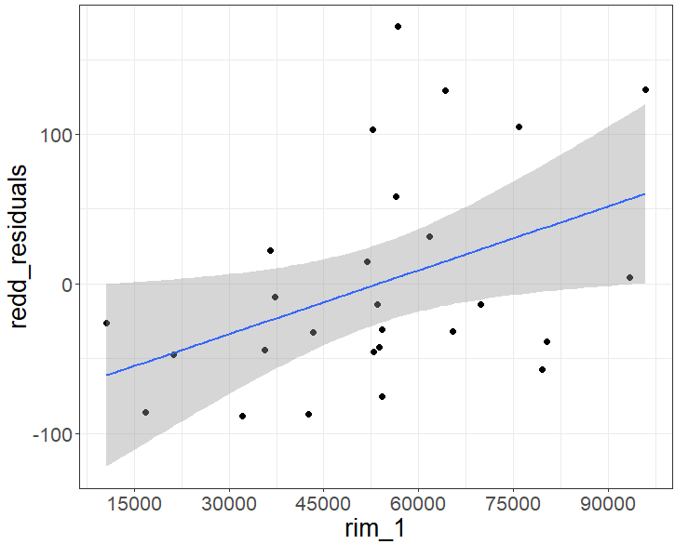

Fig. 3: Minimum annual water storage in Rimrock Lake one year prior (*rim_1*) *vs.* *redd_residuals*. Line is a linear model (p-value = 0.0299) and its 95% confidence interval. *Redd_residuals* are residuals from a linear regression of redd counts *vs.* year from 1994 to 2023 in Indian Creek and South Fork Tieton River.

*Other Factors Potentially Driving Relationship*

A decline in bull trout redd counts following deep drawdowns may be due to entrainment, impacts to the prey base, loss of connectivity between reservoir and stream habitats, changes in water quality, or some combination of these factors. We predicted that if impacts were mediated primarily through the bull trout prey base, we would only observe declines in redds multiple years later. However, we did not find that minimum annual reservoir water storage in Rimrock Lake two and three years prior improved the fit to the data (p = 0.73 and 0.39, respectively, likelihood ratio test). This finding suggests that direct impacts to bull trout are more likely to drive the association between drawdown depth and redd counts the following year.

Alternatively, this association may be driven by a correlation between environmental factors that simultaneously reduce redd counts and create the need for deeper drawdowns. In attempt to parse these causal pathways, we also fit a general model of redd count residuals using two explanatory variables: *rim_1* and snow pack, estimated as snow water equivalent at White Pass on April 1st *(swe_1*). Not surprisingly, *rim_1* and *swe_1* were correlated (r = 0.49). However, the variance inflation factor was low (VIF = 1.31), indicating that despite the correlation between these variables, there is sufficient information in the dataset to parse their individual effects on *redd_residuals*. We found that the *rim_1* (p = 0.021, likelihood ratio test) and not snowpack (p = 0.50, likelihood ratio test) improved the fit to the data.

**References**

Algera, D. A., Rytwinski, T., Taylor, J. J., Bennett, J. R., Smokorowski, K. E., Harrison, P. M., Clarke, K. D., Enders, E. C., Power, M., Bevelhimer, M. S., & Cooke, S. J. (2020). What are the relative risks of mortality and injury for fish during downstream passage at hydroelectric dams in temperate regions? A systematic review. *Environmental Evidence*, *9*(1), 3. https://doi.org/10.1186/s13750-020-0184-0

Courter, I., & Vaughan, J. (2011). *Fish Passage: Hydropower Operations Reduce Bull Trout Entrainment Mortality at Tieton Dam*. Cramer Fish Sciences.

Coutant, C. C., & Whitney, R. R. (2000). Fish Behavior in Relation to Passage through Hydropower Turbines: A Review. *Transactions of the American Fisheries Society*, *129*(2), 351–380. https://doi.org/10.1577/1548-8659(2000)129<0351:FBIRTP>2.0.CO;2

Divens, M. (2024). *Yakima Basin Bull Trout Spawning Surveys 2023*. Washington Department of Fish and Wildlife.

Harrison, P. M., Martins, E. G., Algera, D. A., Rytwinski, T., Mossop, B., Leake, A. J., Power, M., & Cooke, S. J. (2019). Turbine entrainment and passage of potadromous fish through hydropower dams: Developing conceptual frameworks and metrics for moving beyond turbine passage mortality. *Fish and Fisheries*, *20*(3), 403–418. https://doi.org/10.1111/faf.12349

Harrison, P. M., Ward, T., Algera, D. A., Culling, B., Euchner, T., Leake, A., Crossman, J. A., Cooke, S. J., & Power, M. (2020). A comparison of turbine entrainment rates and seasonal entrainment vulnerability of two sympatric char species, bull trout and lake trout, in a hydropower reservoir. *River Research and Applications*, *36*(7), 1033–1045. https://doi.org/10.1002/rra.3617

Hiebert, S. (2004). *Fish entrainment from Rimrock Reservoir, Tieton River Washington, 2004*. USBR. http://www.ybfwrb.org/Assets/Documents/References/Hiebert_et_al_2003.pdf

Hiebert, S., Best, E., Sechrist, J., Swartz, R., Moore, D., Wilson, J., & Kennedy, S. (2003). *Fish Entrainment from Rimrock Reservoir, Tieton River, Washington 2002*. Bureau of Reclamation. http://www.ybfwrb.org/Assets/Documents/References/Hiebert_et_al_2002.pdf

James, P. (2002). *Population Status and Life History Characteristics of Bull Trout in the Yakima River Basin*. Bureau of Reclamation.

Mizell, M., & Anderson, E. (2008). *Monitoring Federally Listed Bull Trout (Salvelinus confluentus) Movements Proximate to Bureau of Reclamation Dams in the Yakima Basin*.

Mizell, M., & Anderson, E. (2015). *Final Report: An Investigation into the Migratory Behavior, Habitat Use and Genetic Composition of Fluvial and Resident Bull Trout (Salvelinus confluentus) in the Yakima River Basin*.

Mongillo, P., & Faulconer, L. (1980). *Yakima Fisheries Enhancement Study*. Washington Department of Fish and Wildlife. http://www.ybfwrb.org/Assets/Documents/References/Mongillo_Faulconer_1980.pdf

Small, M. P., Hawkins, D., & Von Bargen, J. (2009). *WDFW Yakima bull trout report. Phase 3: Genetic Analysis of Yakima Basin Bull Trout (Salvelinus confluentus)*. Washington Department of Fish and Wildlife. http://www.ybfwrb.org/Assets/Documents/References/Small_et_al_2009.doc